Data Cleaning:
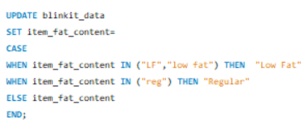.
KPIs:
Total Sales:
Output:
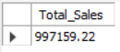

Average Sales:
Output:
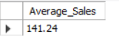

Number of Items:
Output:
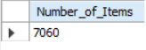

Average Rating:
Output:
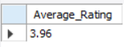

Total Sales by Fat Content:
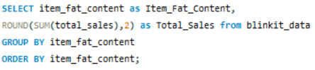
Output:
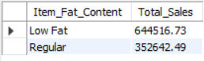

Total Sales by Item Type:
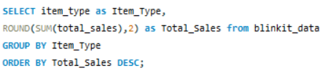
Output:
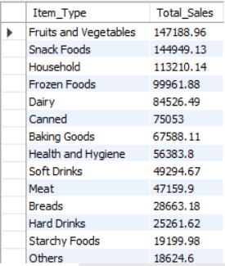

Fat Content by Outlet for Total Sales:
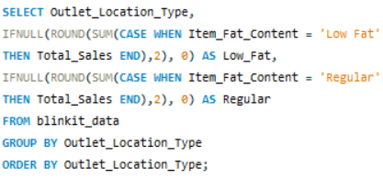
Output:
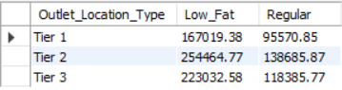

Percentage of Sales by Outlet Size:
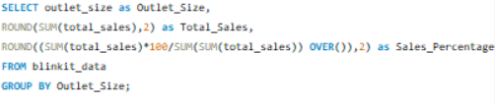
Output:
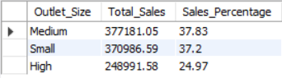

Sales by Outlet Location:
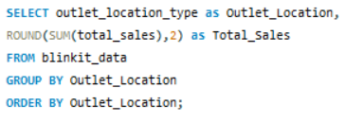
Output:
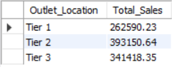

All Metrics by Outlet Type:
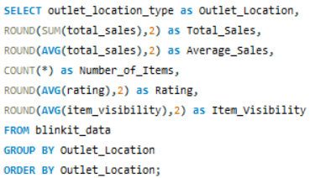
Output:
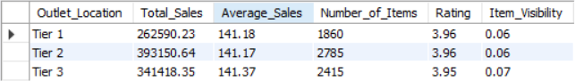

Time-Based Analysis
Year-wise Total Sales:
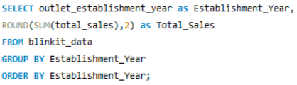
Output:
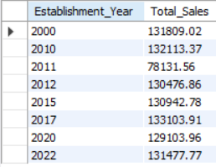

Year-on-Year Sales Growth:
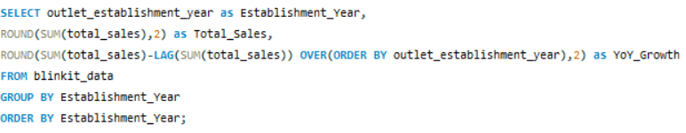
Output:
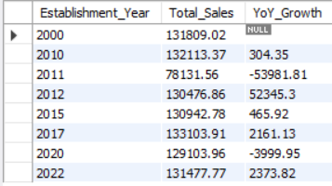
Cumulative Sales Over Years:
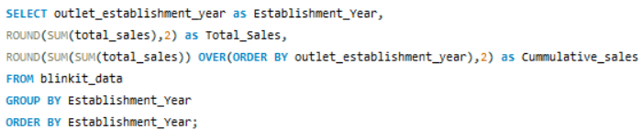
Output:
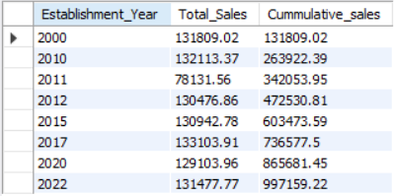

Ranking & Contribution Analysis
Top 5 Item Types by Sales:
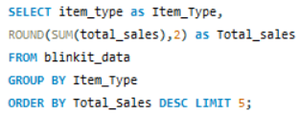
Output:
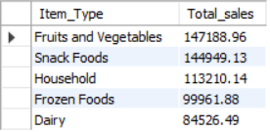

Ranking Outlet Types by Total Sales:
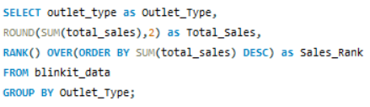
Output:
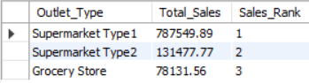

Performance vs Quality Analysis:
High Sales but Low Ratings (Risk Outlets):
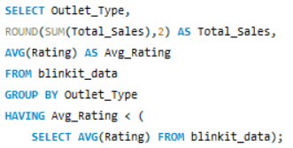
Output:
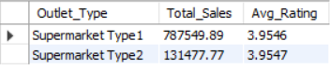
Outlet Efficiency Metrics:
Sales per Item by Outlet Type:
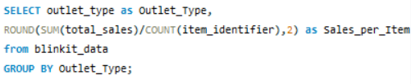
Output:
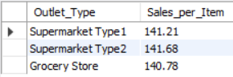

Most Efficient Outlet Size:
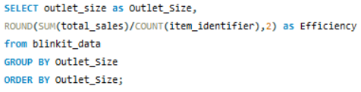
Output:
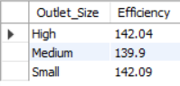

Location × Product Cross Analysis:
Best-Selling Item Type per Location:
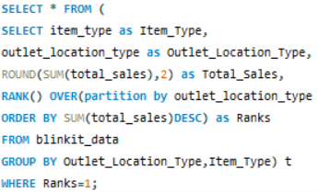
Output:
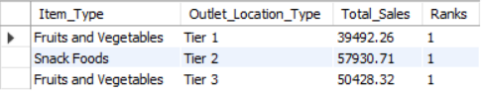

Fat Content Preference by Location:
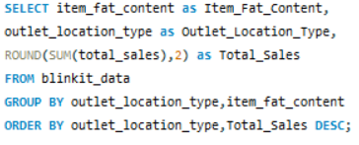
Output:
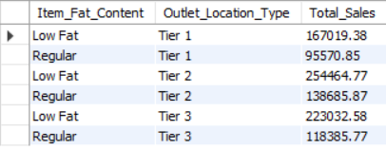

Compare Outlet Sales with Overall Average:
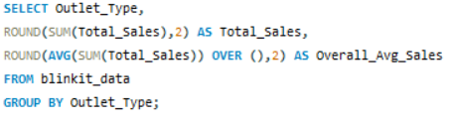
Output:
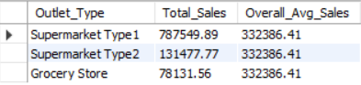

Overall Conclusion
- BlinkIT’s sales are driven by a limited set of high-performing products and outlet types, highlighting opportunities to focus on top contributors for maximum revenue impact.
- Outlet size, location, and establishment year strongly influence sales performance, emphasizing the importance of strategic outlet expansion and optimization.
- Combining sales, ratings, and efficiency metrics provides a holistic view of performance, supporting data-driven decisions to improve revenue growth and customer satisfaction.

